# CG-490 Design

The design goals set out for our project in ELEC 390 were to accelerate an 18g projectile to a velocity of 30 m/s with a kinetic energy of 8J. Through the use of magnetic simulators and circuit simulators we will investigate the requirements for such a device and build off of the knowledge gained last year.

## Switching Circuit Selection

The switching circuit is used to pulse current through the coils. Based on the analysis done in ELEC 390 and using a safety margin of 2 it was decided to design our circuit to withstand switching 100 volts at 250 amps for a period of 10 milliseconds. The circuit was simulated using LT Spice, a popular free SPICE simulator tool. Several designs were tested to determine the optimal configuration. These configurations are discussed below:

### MOSFET vs. IGBT

MOSFET’s are resistive devices whereas IGBT’s have a semiconductor junction. This means that a mosfet will have a variable Vds depending on the current Id in its saturated state. An IGBT behaves more like a BJT with a relatively fixed voltage drop. Power losses in a FET are I^2*R whereas in the IGBT they are Vce*I. This makes IGBT’s better suited for high current applications as the power dissipated increases linearly with current.

In an IGBT, Vcesat represents the Vce voltage that is reached as soon as the bias-current is high enough so that Vce will not decrease anymore. In general, IGBT’s suited to our requirements have a 2.5V Vcesat meaning that regardless of applied current, the voltage drop across the device will always be around 2.5 V (sometimes a little higher or lower depending on current). For this reason, IGBT’s are usually used in high voltage applications where the loss of a few volts does not matter. For the application of developing a 50 V, 250 A switching circuit, this voltage drop represents a loss of over 5% which can be avoided by using MOSFET’s.

### Config 1

The first configuration tested consists of only a few key components including the Mosfet, Coil (inductor), Battery and a switching source. 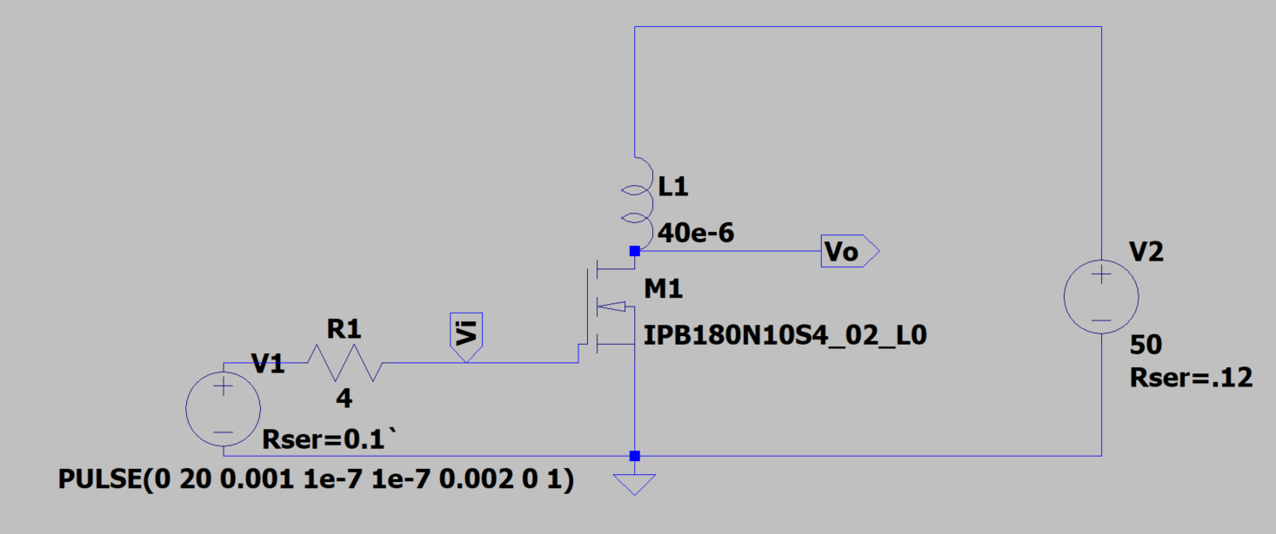

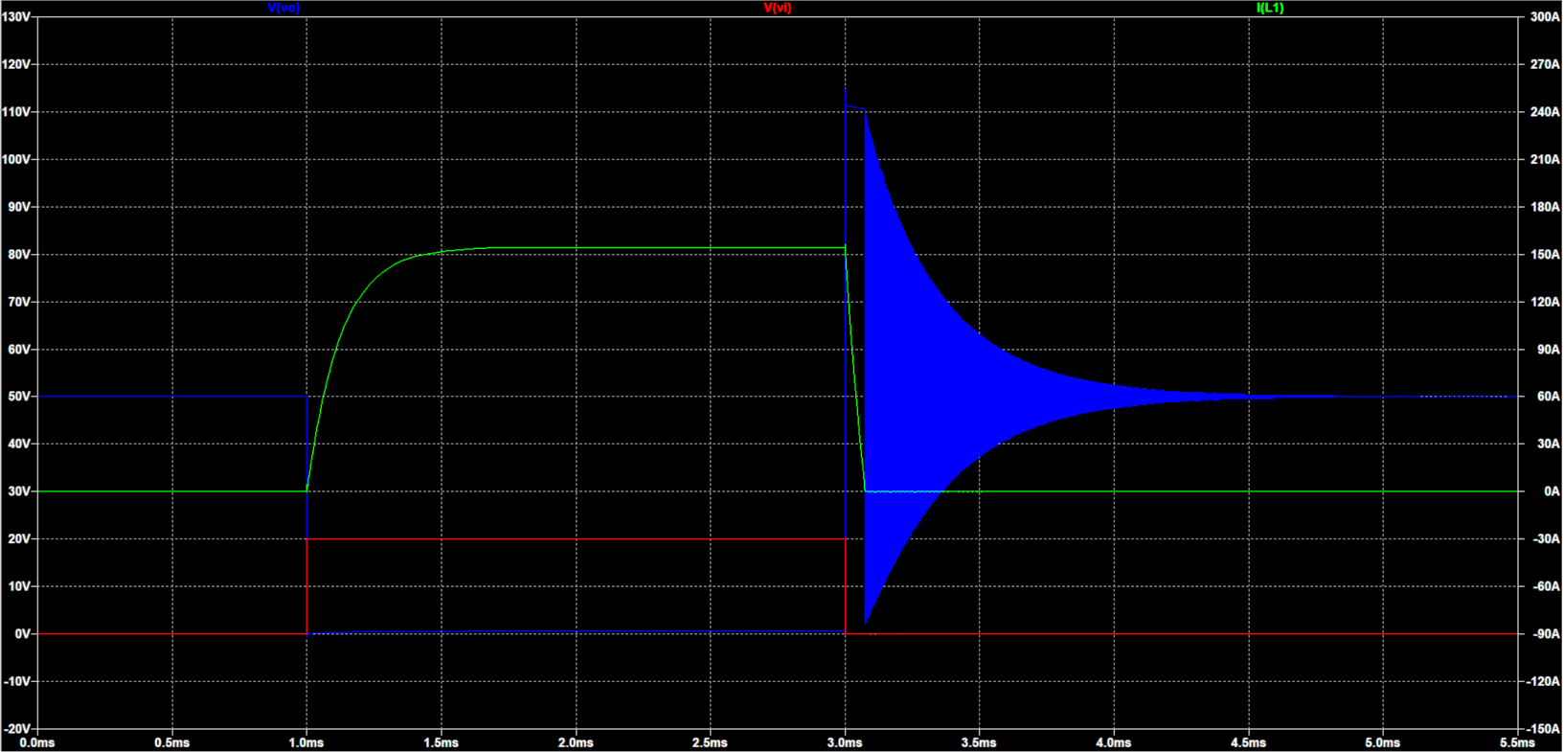

It can be seen that the inductor current (green) ramps to its final value (set by resistances) as defined by the equation V = L di/dt 🡪 I = . To summarize, the current changes slower for coils of higher inductance but this is not important for the scope of this simulation. The main issue with this circuit configuration is the massive voltage spikes present at the end of the current pulse. When the MOSFET switch ‘opens’ there is a very large change in current in a small window of time (large di/dt), resulting in a very large voltage spike. The simulatoion shows this voltage spike as clipping at 110V because of the avalanche breakdown of the FET.

An avalanche current i flows through the resistor R in the base region of the parasitic NPN bipolar transistor. As a result, a voltage i x r appears across the base and the emitter of the transistor. If this voltage is high enough to turn on the parasitic NPN transistor, it passes a current. At this time, if the drain-source voltage is high, the parasitic NPN transistor might enter secondary breakdown, causing permanent damage to the MOSFET.

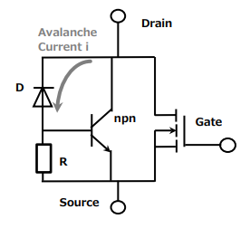

<https://toshiba.semicon-storage.com/info/docget.jsp?did=59466>

We can avoid this problem by using an antiparallel diode or a Zener diode to provide an alternate current path for the coil to dissipate energy into. We could potentially collect this energy using capacitors and feed it back into the system but that is outside the scope of this project.

### Configuration 2

In order to solve the problem with large voltage spikes, an antiparallel diode was added to the circuit to absorb the current from the coil.

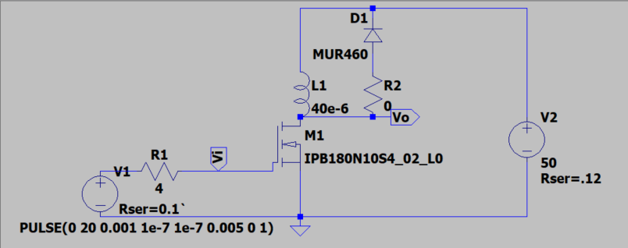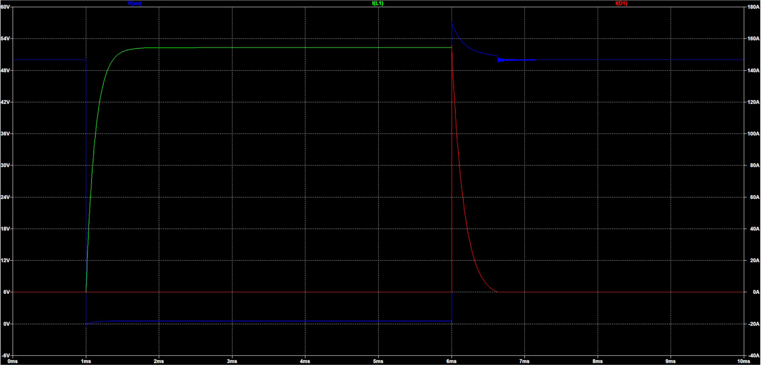

The effect of adding the diode is very clear as the voltage spike seen earlier is no longer present. It should be noted however that the coil current takes about 3 times longer to fall to zero. This has the effect of adding a suck-back effect to the projectile as there is still residual current in the coil which will cause acceleration in the negative direction.

### Configuration 3

The problem of delayed turn off can be combatted through the use of a Zener diode to clamp the Vds to a safe value. The large voltage drop across the Zener diode allows it to dissipate power significantly faster than the standard anti parallel diode configuration.

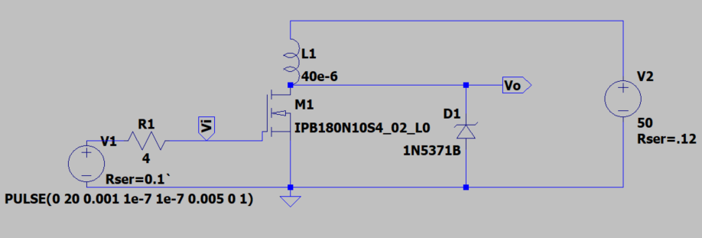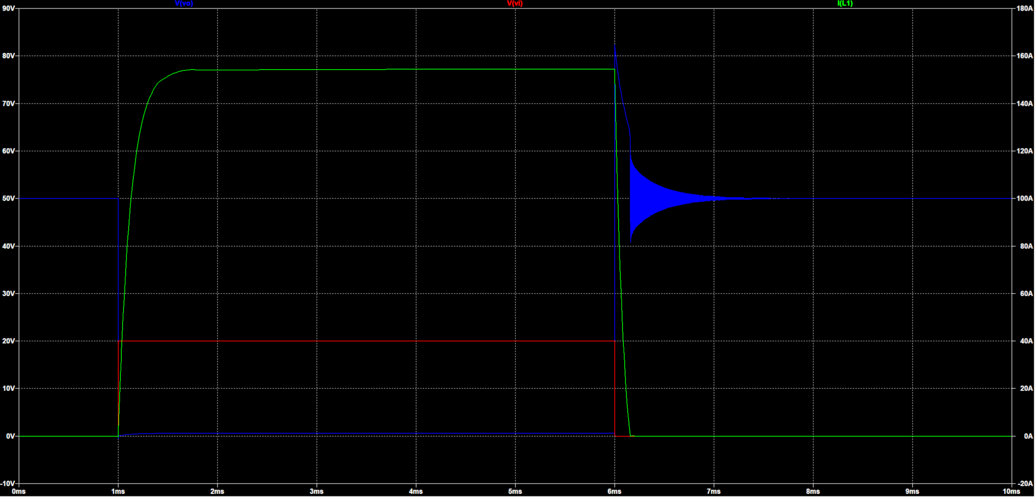

As shown here, the addition of the Zener diode allows for a very fast turn off of the coil because it dissipates the inductive power very quickly across its large voltage drop (P=VxI). There is still a large voltage spike that can be controlled through the clamping voltage of the Zener diode selected.

### Configuration 4

A common topology used in switched mode power supply designs is the push-pull configuration. This configuration uses a second MOSFET to replace the antiparallel diode to actively sink current from the coil. 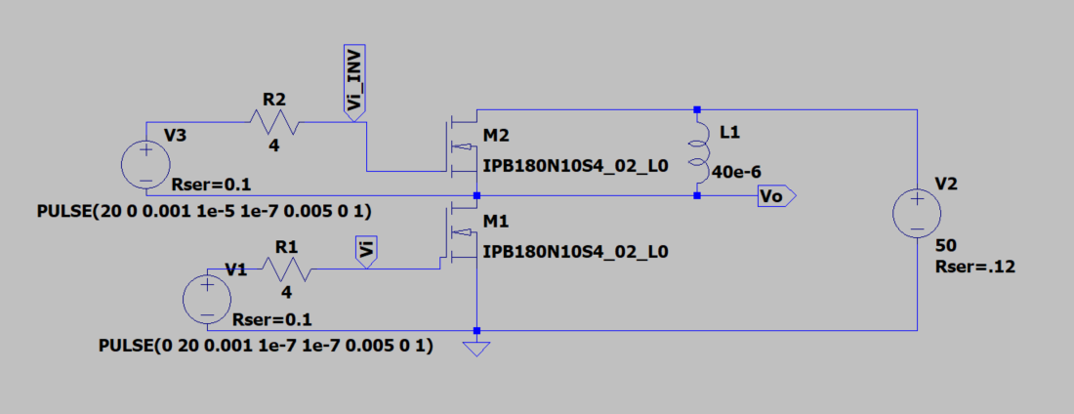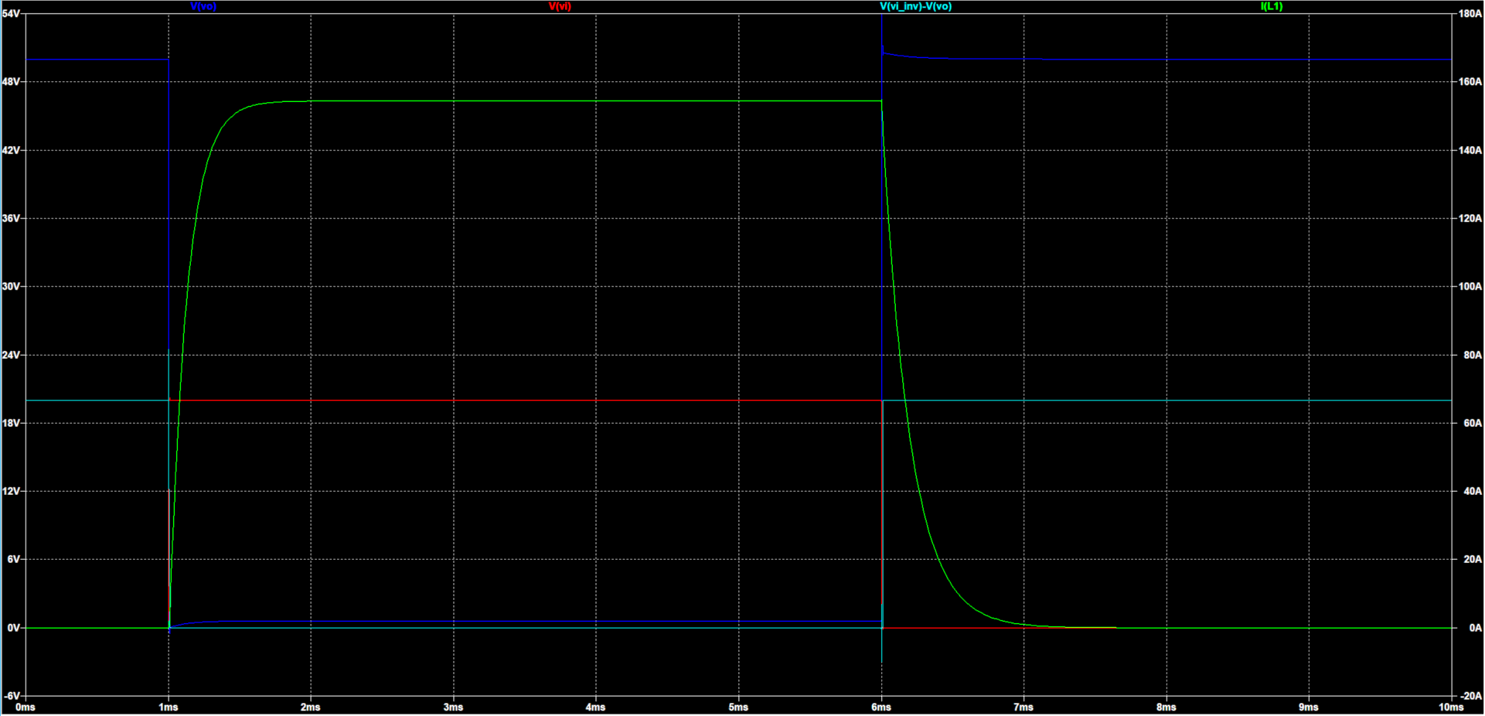

This configuration yielded similar results to the antiparallel diode used in configuration 2 and is significantly more expensive to build, thus will be ignored.

## Switching Circuit Design

It was decided that configuration 3 should be used since it yielded the best performance and minimizes complexity of the circuit. Subsequent simulations will be based around this configuration to determine the optimal component values and gain a better understanding of its limitations.

### MOSFET

In order to avoid failure in the MOSFET, there are many factors to consider, including the Drain-Source breakdown voltage, thermal limitations, current limitations and power dissipation limitations. Conveniently, these parameters are all included on the SOA (Safe Operating Area) plot on the Mosfet’s 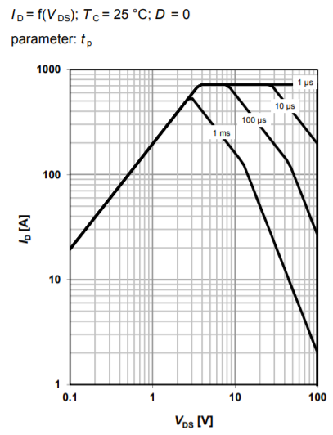datasheet.

Using the SOA diagram, we can determine the maximum safe current and voltage drop for different pulse lengths. Segment 1 shows Id vs. Vds as limited by Rdson. We will be operating our MOSFET in saturation meaning that our Id and Vds will be somewhere along this line. The Rdson Line ends at the horizontal line representing the maximum current the package can handle. The figure also shows maximum ratings for different pulse lengths. If we know that our MOSFET won’t be conducting for longer than 1ms, we can see that the maximum allowable current is 400 Amps and occurs in the ohmic region of the device. If we were to operate the MOSFET in its linear region (NOT SATURATED) we would follow this line along further to the right to find the maximum allowable current for each Vds. This region is limited by the maximum power dissipation of the package and assumes the use of an ideal heatsink. After this line, we arrive at the secondary thermal breakdown line where the temperature coefficient of the device becomes negative. This means that as the FET gets hotter, it allows more current to flow for a specific Vds, thus creating more heat and starting a thermal runaway ending in device destruction. This failure mode is known as secondary breakdown.

Using a maximum on-time for our coilgun of 10 ms, we can extrapolate the pulse length lines on the graph to reach a maximum saturation current of approximately 300 Amps. It is important to turn the FET on and off as quickly as possible to minimize the heat generated during the switching cycle since the FET passes through its linear region. This is especially important when shutting off the device since at this point it is conducting hundreds of amps. As long as we do not exceed this current for a duration longer than 10 ms, and we successfully snub the voltage spikes during switching we should be able to avoid failure of the MOSFET.

### Zener Diode

The purpose of the Zener diode is to prevent massive voltage spikes from killing the MOSFET when the current is switched off in the coils. An appropriate Zener diode must be selected to ensure that it prevents voltage breakdown of the MOSFET, it only conducts when the coil is switched off, and that it is capable of handling the large surge currents flowing through the coil at turn off. In order to prevent breakdown of the MOSFET, the Zener voltage needs to be below the breakdown voltage of the MOSFET. To ensure the Zener diode only conducts when the coil is switched off, the Zener voltage must be greater than the battery voltage used in the circuit. If a Zener voltage lower than the battery voltage is selected, the Zener diode provides an alternate current path through the coil meaning that it will always be energized and will likely result in the failure of the diode as well as poor performance of the coilgun. To ensure the long-term reliability of the Zener diode, we must select a diode rated to handle large surge currents of approximately 300 amps (max current of MOSFET) for a maximum of 1 ms.

It was decided to use TVS (Transient Voltage Suppression) Diodes in place of standard Zener diodes since they are designed with high surge currents in mind. There are four main factors to consider when selecting a TVS diode. The reverse standoff voltage represents the voltage at which only 1 uA of current flows through the diode. The steady state voltage of the circuit should be below this threshold to avoid excessive power loss. The reverse breakdown voltage of the diode represents the voltage at which the diode starts conducting 1mA of current. This is the voltage where the diode begins clamping. The final factor is the maximum clamping voltage Vc which occurs at the peak clamping current the diode is rated for. This value needs to be below the breakdown voltage of the MOSFET at the peak clamping current. The peak clamping current required in the diode must also not be exceeded to avoid risk of failure.

To save on costs, two less expensive TVS diodes will be used together to meet the demands of the circuit. The diodes will be placed in series meaning that the standoff voltage must be greater than Vbat/2, and the clamping voltage must be less than Vdsbreakdown/2. The diodes are placed in series to ensure even conduction of current between the two diodes. If a parallel configuration was used, one diode may conduct most of the current if it has a slightly different Vbreakdown which could result in catastrophic failure of the circuit. The diode selected must be able to handle a peak clamping current equal to the current flowing through the coil in its active state. The time spent at this peak current is dependent on the voltage drop of the Zener diodes as power dissipated is equal to V*I. Through simulation, the optimal pulse width (defined as the time it takes for clamping current to go from peak to peak/2) was found to be 65 uS with a voltage drop of 100 V on the Zener diodes, a coil current of 250 amps and a coil inductance of 40 uH.

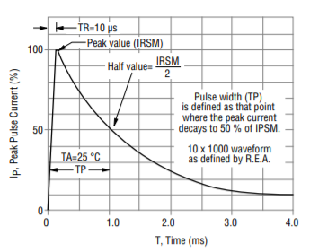

## MOSFET Gate Driver

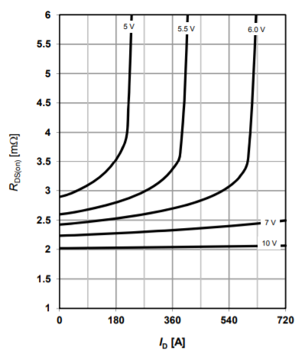The MOSFET gate cannot be directly controlled from the output of the microcontroller. The Arduino pins are only capable of outputting 5v at 50 mA. Driving the gate from the Arduino directly would result in a slow and incomplete turn on of the FET, leaving it in its triode (linear) region. The MOSFET’s drain to source resistance (Rdson) is a function of the gate voltage. The minimum gate voltage for the FET to saturate is approximately 12 volts. We can further improve the on-state resistance by overdriving the gate closer to its maximum voltage of 20 V. The simplest solution to implement this would be to use a gate driver IC to act as a high voltage, low impedance source for driving the gate. The MCP1407 MOSFET driver IC was selected due to its voltage rating of 18v, its high source/sink current of 6A, and familiarity with the device. No SPICE model could be found for this device so it will be simulated as a voltage source with the output impedance of approximately 2 ohms found in the datasheet.

## Completed Circuit

The schematic and associated PCB layout for the prototype circuit can be seen above. The design was simulated with a few modifications in LTSpice. Firstly, the gate driver IC is idealized and replaced with a voltage source with a 2-ohm output impedance. The simulation also does not account for any parasitic capacitance or inductance along any of the PCB traces and may lose some accuracy when it comes to voltage overshoot and ringing within the circuit. It should however serve to provide a solid understanding about what is going on in the circuit and its potential limitations.

The figure above shows the circuit schematic simulated in LTSpice. The model simulates the electrical and thermal performance of the circuit. The Gate driver IC is replaced with a pulse generator with series resistance of 2 ohms and rise/fall time of 40 nS. This should provide an approximation to the actual performance of the gate driver IC. The MOSFET models used in the simulation include parameters for junction and case temperatures which are output as voltages (1V = 1 degree C). The MOSFET case is connected to a heatsink modeling a PCB with an area of 100 cm ^2. The MOSFET will be soldered to the PCB through its drain terminal (the large metal tab) providing thermal and electrical conductivity to the PCB. The battery is replaced with a 50 V voltage source with 120 milliohms of series resistance (equal to 10 milliohms per cell which is reported to be an above average value). It should also be noted that the models for the TVS diodes used in this simulation are very basic and do not reflect the parameters specified in the datasheet.

Electrical and thermal simulations were run for two MOSFETs, the IPB180N10S402 and the STP310N10F7. These MOSFETs were selected due to their very low Rds on values and pulsed current capability.

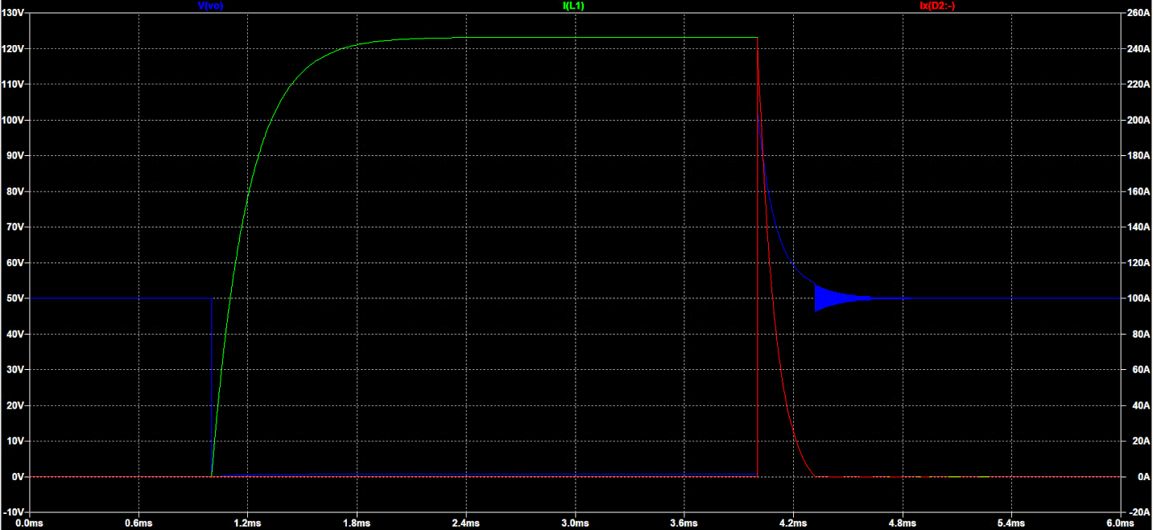

Electrical sim of IPB180N10S4

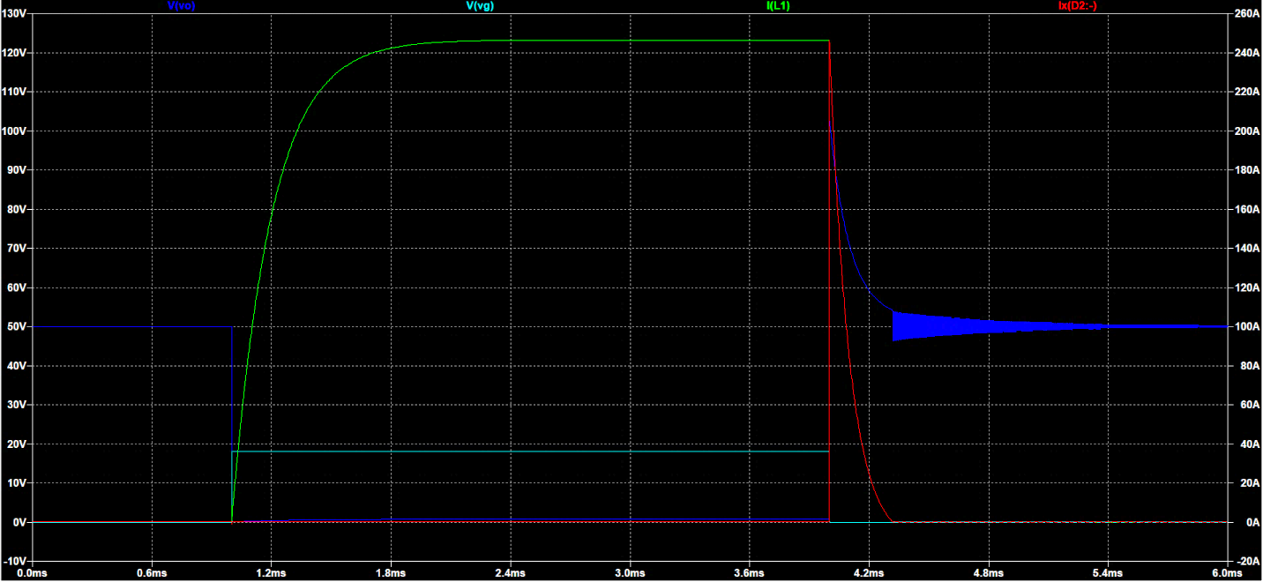

Electrical sim of STP310N10F7

The electrical performance of the two MOSFETs is nearly identical, with the only difference being the increased oscillations in the off cycle of the STP device. Each device reaches a peak current of 247 A (limited by parasitic resistances in the battery, wires, coil, and MOSFET. Each MOSFET has an identical rise time and fall time. Each circuit takes about 0.3 milliseconds to fully dissipate the energy stored in the 40 uH coil and reaches a peak voltage of 100 volts Vds. The actual value of Vds will likely be lower as specified in the TVS diode datasheet (the SPICE models are very basic).

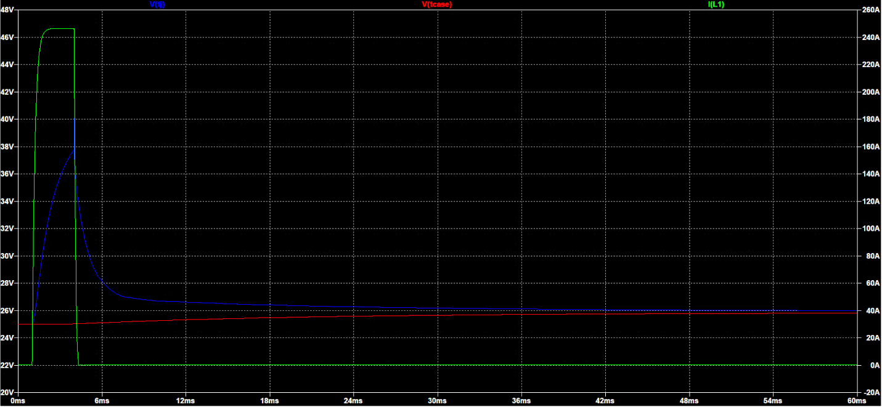

Thermal sim of IPB180N10S402

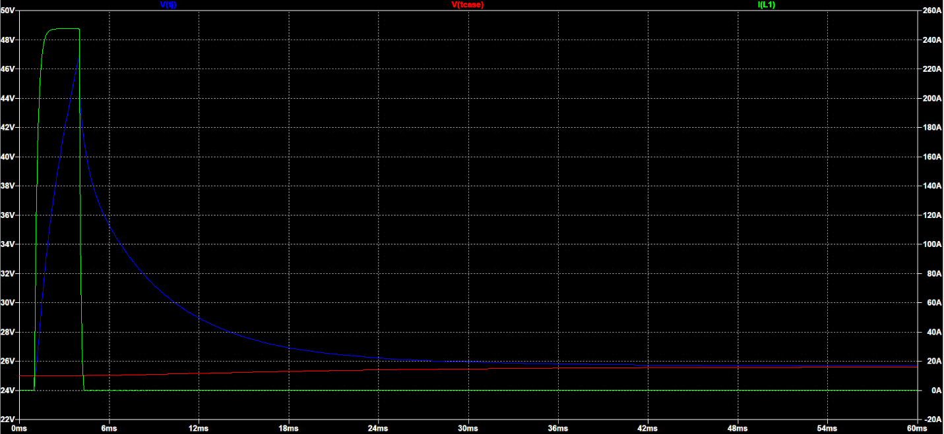

Thermal sim of STP310N10F7

The thermal performance of the two MOSFETs is quite different with the STP device experiencing much more heating during the switching cycle. Each device was simulated with a starting case temperature of 25 degrees C and was simulated over a 60 mS window. The IPB device reached a peak die temperature of 40 degrees while the STP device reached a peak die temperature of 47 degrees. In each instance, the case temperature reached a final value of 25.6 degrees.

As a result of these simulations, it was decided that the circuit prototype was ready to be tested to gain some real-world data to base further decisions off of.

## Optical Triggering Circuit

The optical triggering circuit is responsible for detecting the position of the projectile and generating a trigger pulse to activate the switching circuit. For safety reasons, the pulse length should be limited to avoid failure of the MOSFET. The main circuit components are an LED + phototransistor pair, an LM393 dual comparator IC, and some passive components. The LED and phototransistor were selected to use 900 nM to avoid interference from visible light.

The phototransistor responds to varying intensity of light by changing the current allowed to flow between its collector and emitter terminals. It operates identically to a normal BJT except that its base is biased using the electron hole pairs generated across the B-E photosensitive diode. We can pull this current through a resistor to create a varying voltage drop and compare that voltage to a tunable reference voltage using a comparator IC. When the light beam is broken by the projectile, less current will flow through the phototransistor, causing the comparator to output a low signal.

The next stage of the circuit is used to limit the pulse length to a time set by the time constant of R8 and C1. When the first comparator outputs a low signal the PNP transistor Q1 enables current to flow through R8 charging C1. The increasing voltage across C1 is compared to a reference voltage generated by R6 and R7. When the capacitor is charged past this reference voltage the comparator pulls its output low, thus limiting the pulse length. The capacitor discharges through R10 and the cycle is ready to repeat after 100 ms.

## Coil Selection

The coil is used to generate a powerful magnetic field using the high current pulse generated by the switching circuit. The length, width, inner/outer diameter, and number of turns are all very important parameters when it comes to coil inductance and magnetic field intensity. The dimensions of the projectile as well as projectile material are very important parameters governing the magnetic flux density (for a given field intensity) and force experienced by the projectile. Explain some equation stuff, whatever. Due to the complex nature of the problem, FEMM, a finite element magnetics simulator will be used to simulate the force experienced by the projectile. This data will be used to determine the effect of changing each parameter and will lead to more informed design choices.

### Basic coilgun simulation

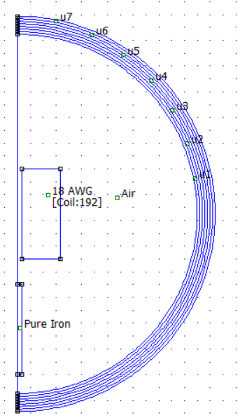The most basic simulation we can run involves stepping the projectile through the coil in finite steps and calculating the force experienced by the projectile at each position. First, we must define the necessary components in FEMM.

First, FEMM was configured to run an axisymmetric magnetic simulation meaning that the geometry we define is rotated 360 degrees about the z-axis. Next, boxes were drawn defining the coil and projectile regions with the dimensions decided upon in our 390 final report. Material properties were defined for each region; pure iron for the projectile, air for the surroundings, and a coil of 18AWG wire with 156 A flowing through 192 turns of wire. The circular boundaries surrounding the simulation area define the interior and exterior regions of the simulation (we cannot simulate infinite space).

The results of running this simulation are shown below.

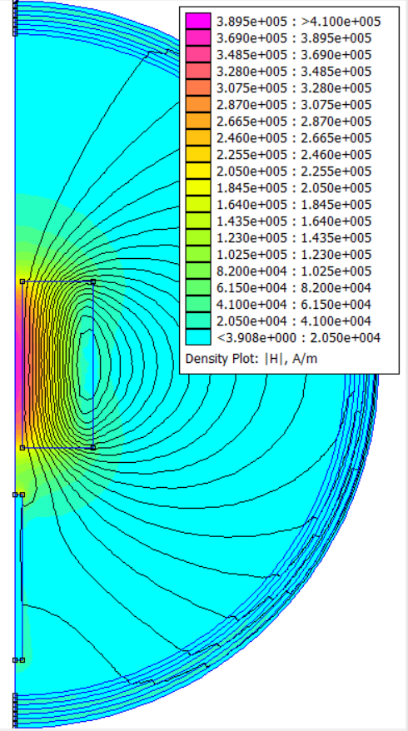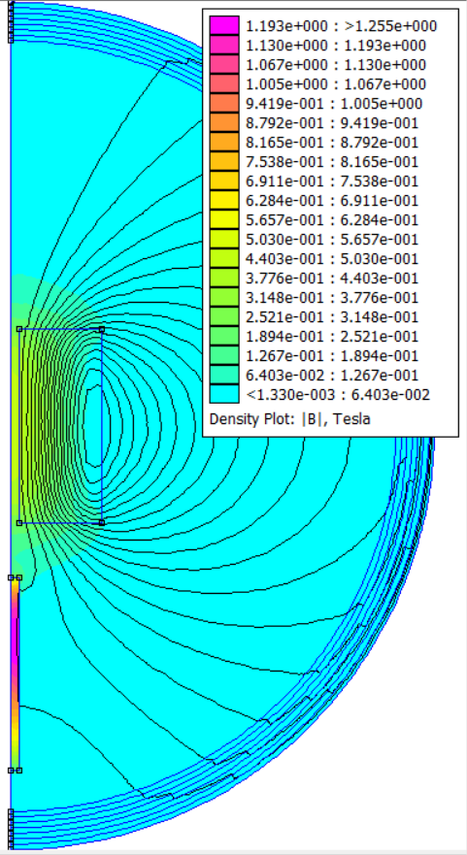

Using FEMM, we can calculate the magnetic field intensity and flux density at all points within the simulation region. Using FEMM it is also possible to select an area and integrate the force applied to that block. FEMM also comes with several scripting options including a Python library, PyFEMM. Through PyFEMM, Python will be used to sweep various parameters including projectile length, projectile radius, coil length, coil inner and outer radius, coil inductance, etc.

### Barrel Thickness

With all other parameters fixed, the inner radius of the coil is stepped from 6.35mm to 11.35mm while maintaining a constant coil thickness (outer dia – inner dia is fixed). The simulation ignores changes to coil resistance as a result of changing wire lengths for a fixed number of turns and maintains a fixed current flowing through the coil.

It is clear from the data that the highest force on the projectile occurs with the smallest barrel thickness but does not drop dramatically with increased thickness (22.7N to 21.5N). As a result of this simulation, barrel thickness will not be a key deciding factor when making final design decisions although it will be minimized within reason.

### Projectile Length

In this simulation, the projectile length is swept while fixing all other variables. The purpose is to determine whether it is optimal to have a projectile that is shorter, equal in length, or longer than the driving coil.

From analysis of the simulation data, a plot of velocity vs. position for projectile lengths of 1cm to 13cm with a 7cm long coil were tested. All projectiles have a radius of 3.2mm. From the figure, it is clear that the peak velocity is reached with a projectile slightly shorter than the coil length. This configuration is optimal to the optically triggered design as we will shut down the coil when the projectile passes the light sensor. Using a projectile of the same length as the coil will result in the coil being shut down just as the projectile is approaching its peak velocity.

The maximum velocities and energies were calculated for each coil length, producing the figure above. Based on this data it can be seen that the kinetic energy gained increases linearly with length until the projectile is slightly longer than the coil. Using a shorter projectile results in a small increase in velocity with a large decrease in kinetic energy. Furthermore, the figure assumes that the coil can be switched off at the exact moment the projectile reaches its maximum energy which would be difficult using armatures with lengths not equal to that of the coil. This confirms that our best option is to use projectiles with the same length as the coil.

### Coil/Projectile Dimensions

The length and inner radius of the coil (radius of projectile) are swept to determine the optimum configuration to meet the project goals. The coil parameters change to maintain a fixed resistance of 0.1 ohms while matching the length and inner diameter of the projectile. This forces each iteration to have the same peak coil current. Each coil will have a varying inductance which changes the energy stored in the coil. Larger inductances will take longer to fully turn on or turn off resulting in lower efficiency. The effects of changing RL time constants are not taken into effect with these measurements. These effects will be measured using a time stepped simulation later in the report.

As can be seen in the figure above, very long coils transfer the most energy to the projectile while shorter projectiles have a higher peak force. Longer coils are more suited to applications where efficiency is not a priority and where projectile energy and simplicity are most important. Filling the same area with many smaller coils (2-3cm) would result in a higher space efficiency efficiency and energy output but at the cost of added complexity.

This is confirmed in the above figure showing the maximum velocity and energy for each coil/projectile length. This figure combines simulations that held a constant coil resistance and a constant coil inductance. The trend for each case is similar.

Based on these results, the width will be swept while holding the length constant at 40mm.

It can be seen that larger radii achieve higher peak forces and deliver more energy to the projectile.

The energy delivered to the projectile appears to be linear until a radius of 5mm at which point the efficiency begins to roll off. The change in velocity appears to be linear across the entire simulation sweep. Based off of this data it appears that the optimal projectile radius for delivering energy while maintaining a high exit velocity is around 4.5 mm.

In order to obtain more accurate results, a time-based simulation was run in which the projectile’s position, velocity and acceleration were calculated as it passed through the first stage coil (Vi=0). The length and radius were held at 40mm and 4.5mm, respectively while sweeping the inductance of the coil used. The simulation uses the current waveform generated using an LT Spice simulation of the switching circuit with the associated coil inductance and resistance parameters. Additionally, the simulation accounts for the optical triggering mechanism which will be used. The coil is turned on when the projectile passes a point 0.5cm before the coil and turns off when the back of the projectile passes that point. The results of this simulation sweep can be found below.

As expected, the projectile velocity increases with inductance since the force on the projectile is proportional to N * I. As the inductance increases, it takes more time to ‘turn on’ and ‘turn off’ since more energy is stored. Eventually, we can expect to see the velocity drop as the projectile begins to experience more suck back and the coil reaches a lower peak current due to increased resistance.

The relationship between velocity and efficiency can be seen above. A coil inductance of 200 uH was selected since it provides the highest exit velocity while maintaining relatively good efficiency. This coil geometry also reduces the load on the switching circuit since it operates at a reduced current.

It should be noted that using a high inductance coil in subsequent stages would not be the optimal solution due to the speed of the projectile. In order to deliver the most energy, the current pulse needs to be able to turn on and off quickly. To prove this, another simulation was run with a starting velocity greater than zero. For the purpose of this simulation, we will use a value of 15 m/s as the starting velocity.

From the data it can be seen that the optimal coil inductance goes down as starting velocity increases. For this reason, subsequent stages must be designed with this in mind and one fixed coil geometry is not optimal for achieving maximum efficiency.